Date:

[CLOUD COMPUTING]

Practical: 5

AIM:

EyeOS ( Virtual Desktop Configuration)

Submitted By: Samip Shah
Enrollment No: 15012011045


GANPAT UNIVERSITY
U. V. Patel College of Engineering
Computer Engineering Department

- INTRODUCTION
There are a number of online operating systems available today, and the number is steadily growing .
“ EyeOS is a web-based open source platform designed to hold a wide variety of web applications over it. “
It looks like a regular PC operating system, but the "trick" is that it can be accessed from anywhere. If you travel all the time, or you don't own a PC or laptop or move often, then you can access EyeOS from an Internet Cafe.
All you need is a web browser, Internet access and EyeOS is there for you, always, all the time. With eyeOS you can organize and centralize your files and documents, play your media, work with Word documents and much, much more.

EyeOS is an open source web desktop following the cloud computing concept.
- It is mainly written in PHP, XML and JavaScript.
- It acts as a platform for web applications written using the EyeOS Toolkit.
- It includes a Desktop environment with 67 applications and system utilities.
- It can be accessed from Windows, Linux or Macintosh computers or from mobile devices that support the technologies. EyeOS is one of those cloud computing operating systems.
EyeOS lets you upload your files and work with them no matter where you are.

- Eyeos can be Understand in just 3 words :-

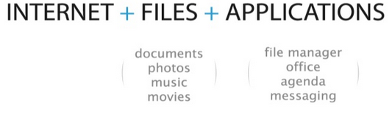

- HISTORY

Establishment: In 2005, a group of young people worked together and put all their efforts in a new project, a new open source web desktop, EyeOS.

August 1, 2005: The first publicly available EyeOS version was released as EyeOS 0.6.0. At the time, it greatly participated in creating the definition of a web operating system and acted as a concept. Quickly, a worldwide community of developers took part in the project and helped improve it by translating, testing and developing it.

June 4, 2007: After two years of development, the EyeOS Team published EyeOS 1.0. Compared with previous versions, EyeOS 1.0 introduced a complete reorganization of the code and some new web technologies, like eyeSoft, a portage-based web software installation system.

July 2, 2007: With the release of the 1.1 version, EyeOS changed its license and migrated from GNU GPL Version 2 to Version 3.

October 29, 2007: 1.2 version was launched with full integration compatibility with Microsoft Word files.

January 15, 2008: EyeOS 1.5 Gala was liberated. The first version that supported both Microsoft Office and OpenOffice.org file formats for documents, presentations and spreadsheets. It also had the ability to import and export documents in both formats using server side scripting.

April 25, 2008: EyeOS 1.6 included many improvements such as synchronization with local computers, drag and drop, a mobile version and more.

January 7, 2009: EyeOS 1.8 Lars featured a completely rewritten file manager and a new sound API to develop media rich applications.

April 1, 2009: 1.8.5 version incorporated a new default theme and some rewritten apps like the Word Processor and the Address Book.

December 29, 2009: EyeOS 1.9 was released followed up with 1.9.0.1 release with minor fixes on February 18, 2010.

March 3, 2010: EyeOS 2.0 was released which was a total re-structure of the OS operating system.
July 28, 2010: EyeOS 2.2.0.0 was released.
December 14, 201:EyeOS 1.9.x was released with the goal to continue the work EyeOS has stopped on 1.9.x.
May 17, 2011: EyeOS 2.5 was released.

- EYEOS ARCHITECTURE

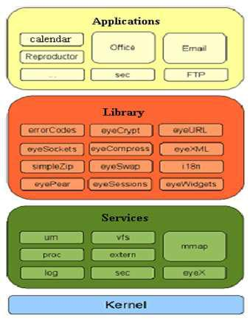

Fig1: Architecture of EyeOS

- Libraries:
Errorcode:
The errorCodes library exists to cover this need, implementing a unified and extensible method to report errors.
SimpleZip:
A powerful library to create ZIP files.
eyeURL:
allows to request URL.
eyeXML:
allows to work with XML files (read,write..)

For example, it is used to store configurations, transport data and messages, among much other uses.
eyeWidgets :
It library provides a quick form of creating graphical interfaces in eyeOS.
eyeSockets:
eyeSockets provides a class that offers a clean, quick and effective programming when establishing and using a connection.

Eyecrypt:
Encrpt the data.
Eyesession:
The eyeSessions library provides an abstracted method to obtain and save variables and arrays in the session.
Eyepear:
PEAR is a framework and a distribution system for reusable PHP components. In eyeOS only the framework is used (the collection of its libraries), having to do few little modifications to totally adapt a library from PEAR to eyeOS.
- Services:
Services: lower-level functions(such as files, users or processes)
UM(User Manager):
The UM service manages the users in the system and provides the methods necessary for registering, logging in, obtaining the path to a user's home, etc.
VFs:
It is the EyeOS file system.
MMAP Message Mapping:
MMAP is responsible for routing every received message in the server to the applications.
you must know that MMAP is an automated service: it does not require any interaction with the developer at all.
PROC :
PROC is responsible for the process managing, and provides methods to
launch, end, list processes, etc.
EyeX:
The eyeX service is the responsible for managing the response XML sent by the server.
Sec:
Sec is responsible of making eyeOS run in a secure environment.
Log:
It works autonomously registering the system's activity to log files, annotating the time and user of every action.
- Kernel:
The eyeOS has a kernel which contains all sub implementations for the various tasks like Memory Management, File Management, Data Management etc.

- PROCESS INSIDE EYEOS
Every time an application is executed, an entry in the process table of a user is created. This entry is an associative array that contains information about the name, Process ID ,checksum , currentUser and the time it was launched. In the default installation, the process table is a session variable named 'ProcessTable'. By default, an EyeOS application can have multiple instances of itself running flawlessly. Every instance has its own entry on the Process Table and has its own information separately from the others. Despite that behaviour, a programmer can make an application to avoid having multiple instances by looking up the name of the application in the process table.

- APPLICATION DOMAIN

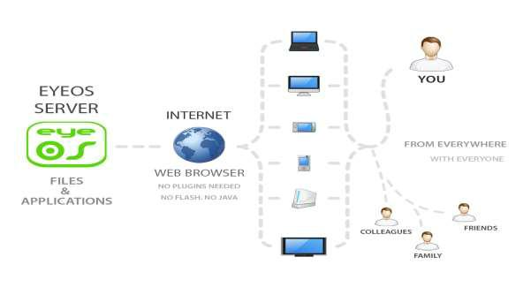

Fig 2: Application Domain

- EyeOS provides system for the users where they work with EyeOS and all its applications,including Office and PIM ones. EyeOS provides a toolkit to create new applications easily.
- EyeOS can provide schools and universities with a full web platform where students, teachers and parents will have a personal yet collaborative desktop to work and, communicate between themselves and get organized inside and outside the school.
- With a private server, EyeOS can provide city councils, public library networks, free Internet points and other public environments the perfect system for their users to have a web place to work and communicate with the network managers, registering once and using it from every point.

- GOALS OF EYEOS

- Being able to work from everywhere, regardless of whether or not you are using a full-featured, modern computer, a mobile gadget, or a completely obsolete PC.

- Sharing resources easily between different work centers at company, or working from different places and countries on the same projects.

- Always enjoying the same applications with the same open formats, and forgetting the usual compatibility problems between office suites and traditional operating systems.

- Being able to continue working if you have to leave your local computer or if it just crashes, without losing data or time: Just log in to your EyeOS from another place and continue working.

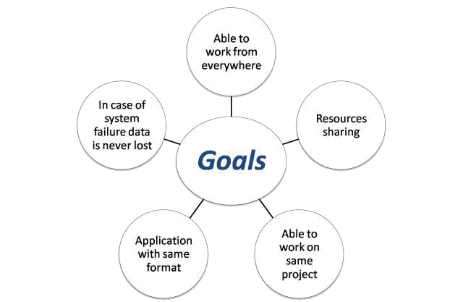

Fig 3:Goals of EyeOS

- FEATURES

- Ubiquity: Access your documents, files and applications from anywhere and any device.
- Flexibility: From the small business to the big corporation. Also for individual use. There is an eyeOS for you!
- Integration: The eyeOS architecture makes easier and faster the integration of any web application that you use.
- Simplicity: From its first steps, eyeOS has been planned and created to be intuitive and easy to use.
- Collaboration: Share files and edit them in a real-time collaboration suite with other users.
- Privacy: Decide where your files are: You can have your own eyeOS server!
- Security: Control your eyeOS. You are who manage roles and permissions for each user.
- Low costs: All in one in a single platform: the best way to optimize time and resources.
- Desktop: The desktop is similar to that of a regular operating system. It can be themed based on your preferences; it can run applications, and supports translations of up to 30 languages.
- Office-related tasks: eyeOS supports MS Office and OpenOffice.org documents, spreadsheets and presentations. On top of that, it has a simplistic Personal Information Management (PIM) system that supports calendars and contacts (with a basic import/export facility in vCard format).

- ADVANTAGES/DISADVANTAGES

ADVANTAGES:

- Portability, Decentralization
- Browser with java support is more enough
- Platform independent
- World wide Availability
- Remote storage facilities

DISADVANTAGES:

- Security
- Need for fast connection performance

- How to Configure

Before proceeding with EyeOS installation, please note basic required software to be installed.
- Install XAMPP server Software Click here to download
- Any Browser like: Chrome, Mozilla, and Internet explorer etc.

Step 1: Getting the source code: Click here to download source code
- Once eyeOS_1.9.rar file is downloded extract the file. After that go to the location where the xampp software is install ,open that folder and select htdocs folder and open it and in that folder . Create the New Folder and set its name eyeos
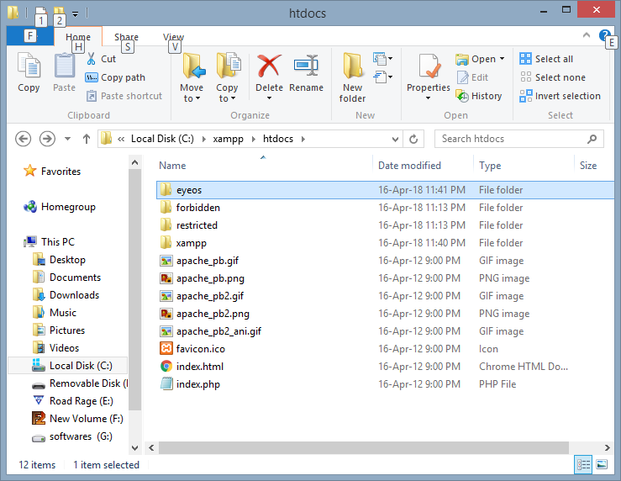

- Whatever file in extract folder Simply Copy that file and Paste it into eyeos Folder.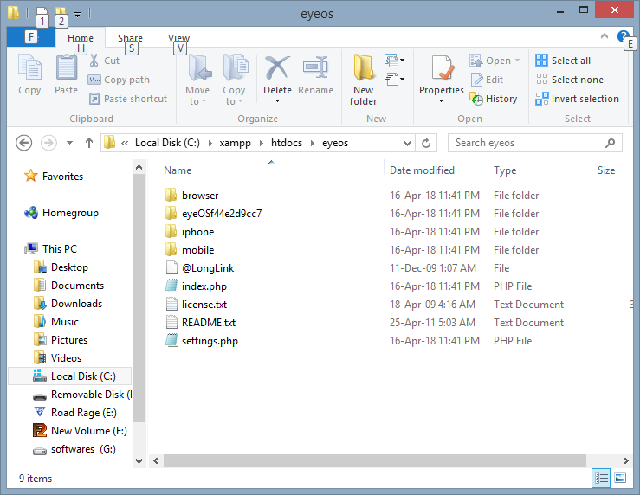

- Open the XAMPP Control panel Software and start the Apache and my sql Services.
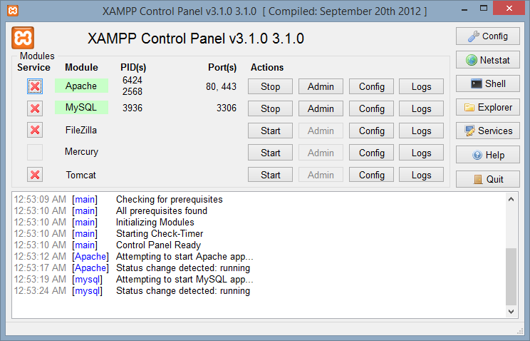

Step 2: Start installing EyeOS:
- Then open browser and in URL type :http://localhost/phpmyadmin
In that create new database, give database name as “eyeos” and click on the create button.
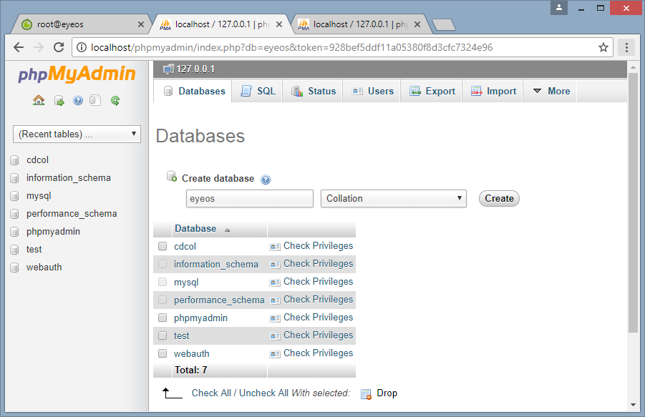

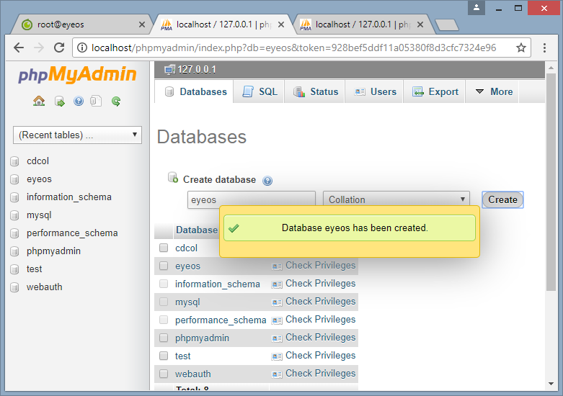
- Then open new tab and in URL type: http://localhost/eyeos/installer

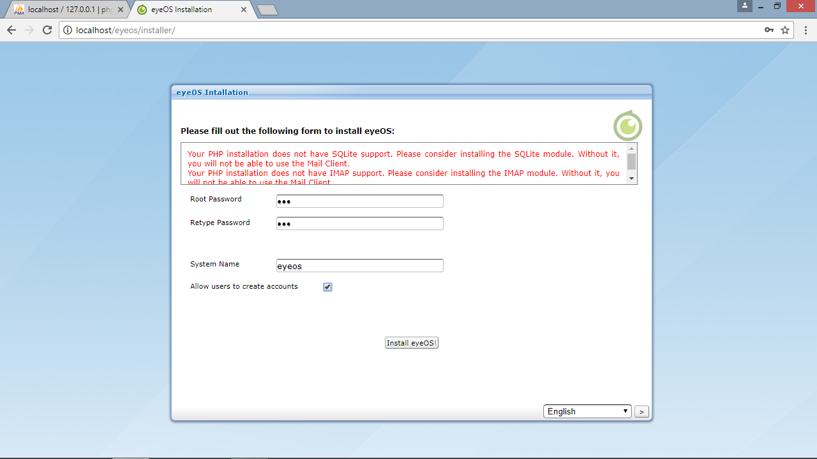

- Enter your username & password and press enter.
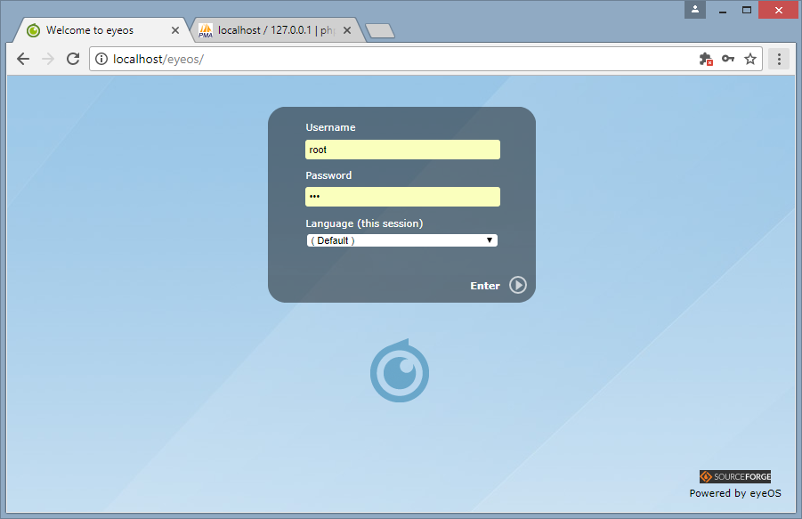

- You will enter home screen of eyeos .
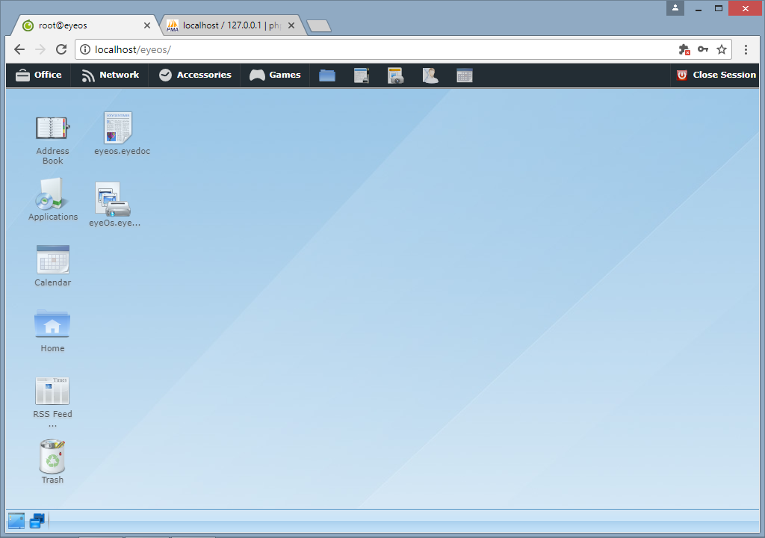

- RESOURCE SHARING
(**Note : You must first turn off your Firewall & must Disable your Virus protection )

1. Open your pc which having eyeos,Xampp already installed and then open cmd ,after that type ipconfig and ping your pc with Another pc.
( which don’t have Eyeos & Xampp )
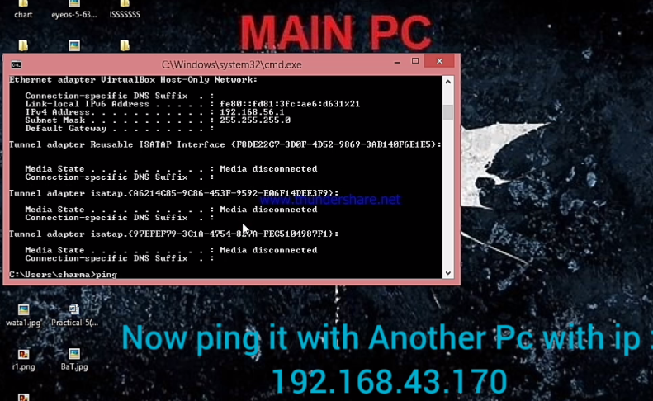
2. Now open your Xampp Server and then go to :
Apache >Config>Apache(httpd.conf)
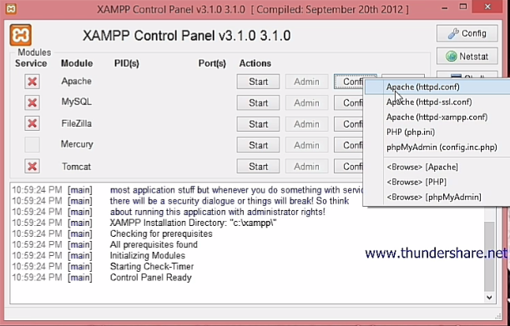
3. Open httpd.conf and search for localhost then change its value 80 to your Pc ip address ( my main pc ip is :192.168.43.163 )
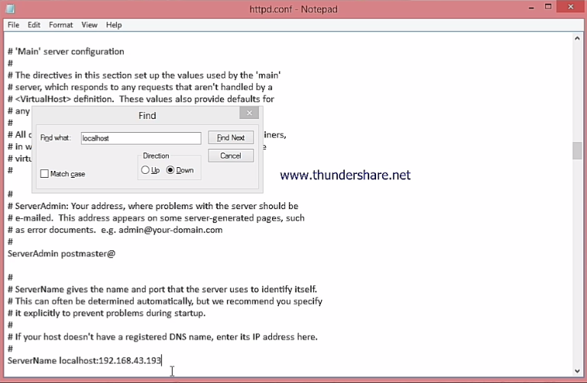

4. Save it and start your Apache and Sql server.
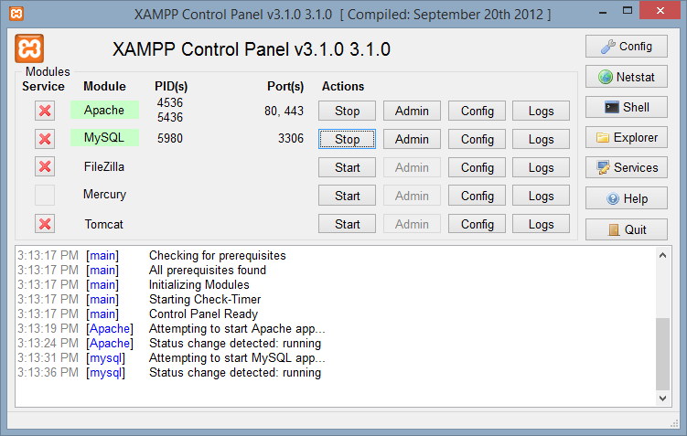

5. Open your Browser and search url http://localhost/eyeos
You will login into your Eyeos Account

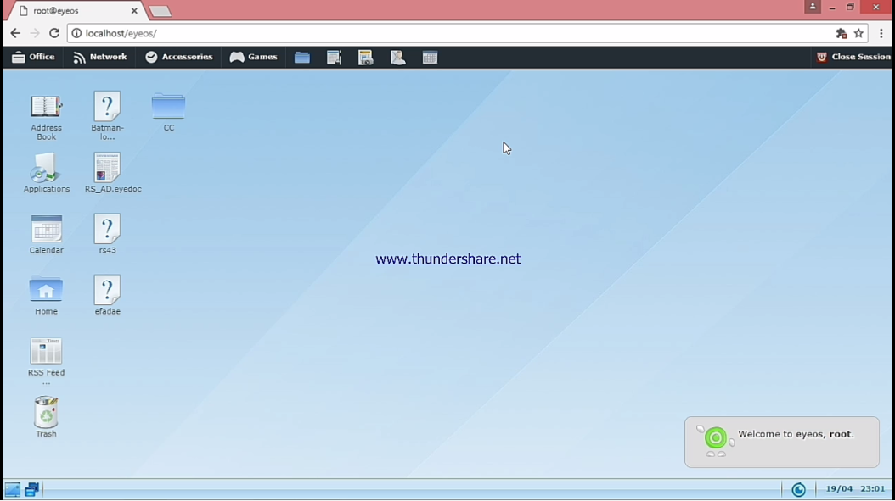

- Now Open Another pc which don’t have Xampp & Eyeos ,open cmd > ipconfig now ping it to Main pc ip address.
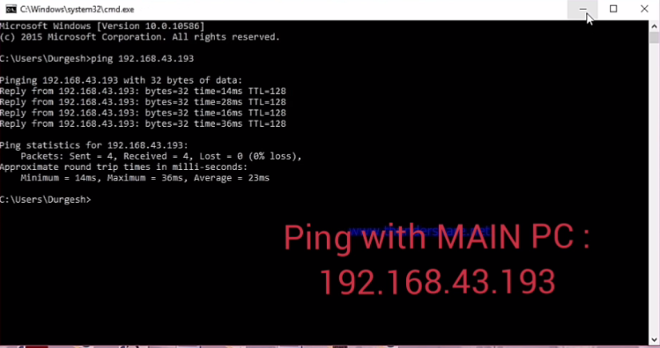

- In Url Enter :- Main pc ip address/eyeos/ ,log in into eyeos account by username & password .
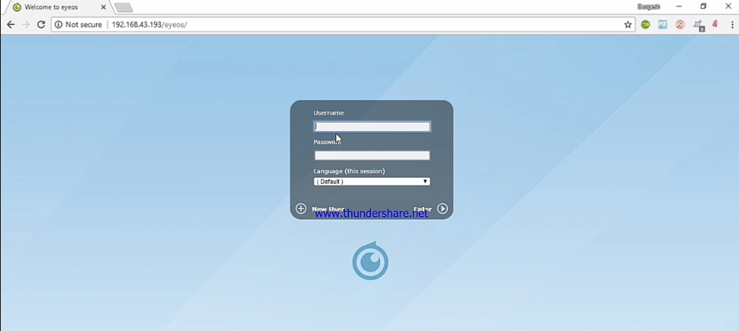

- Now you are enter into Eyeos Account
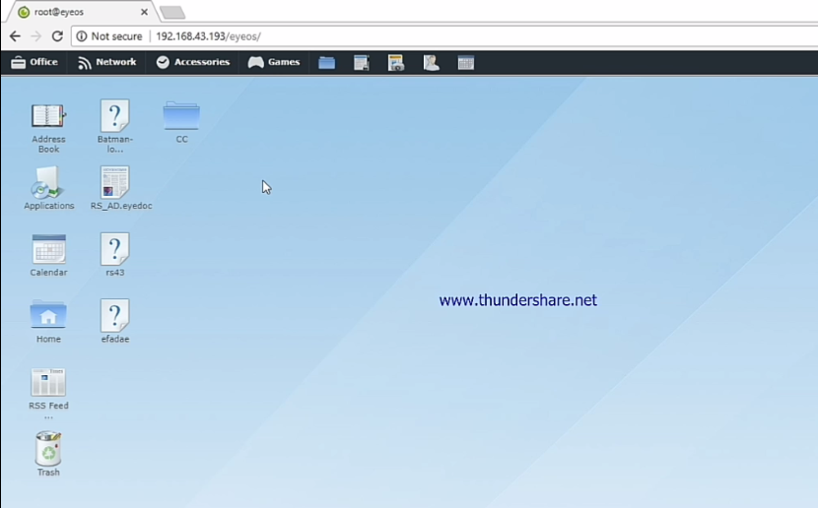

- Now Create New folder in Your Main Pc and refresh your Browser in another pc you will see the same folder is created
(I have created CC 2 folder )
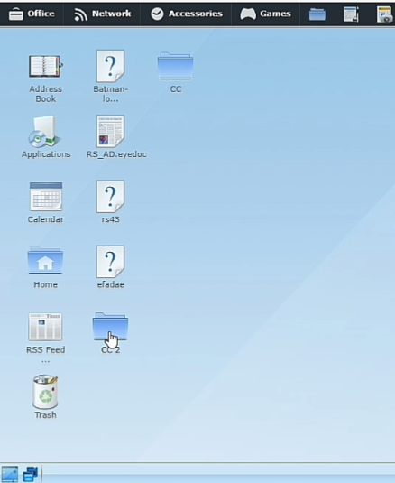

- REFERENCES

- www.seminar4u.com/EyeOS_technology

- www.wikipedia.com/EyeOS_technology

- www.EyeOS.org

- www.google.co.in/EyeOS technology

- www.EyeOS-app.org

